THREE CHESS GENIUSES
Three Men Clever Enough to Give Up Chess !

“Chess mastery is the supreme example of concentrated mental power exercised on insatiable futility.” E.G. c1937.
“Chess…. Is a foolish expedient for making idle people believe they are doing something very clever, when they are only wasting their time.” George Bernard Shaw 1881

This article is about three young men who were among the leading Welsh junior chess players of their day and gave up all competitive chess to concentrate on their careers. If only we had all been wise enough to do the same!!
Walter Marshall
1932-1996

Many Welsh chess players have soared to great heights in the world of science and business, a world away from the chess boards that they grace in their youth.
Walter Marshall, from St. Illtyd’s College, Cardiff, played chess for Wales the first time this country participated in the Glorney Cup in 1949. He played on Board 1 and was still on top board the following year.
The forerunner of the World Junior Championships was held in 1950 in Birmingham when 20 players from 9 different countries competed including F. Olafsson (Iceland) and J. Boey (Belgium). Marshall was the Welsh representative, lost only three of his nine games and finished joint 9th on 5.5 points. The tournament was won by B. Haggqvuist of Sweden.
This is his recollection of the 1949 event as published in the British Chess Magazine 1984.:
“My most vivid recollection is arriving in Birmingham in 1949 captaining the Welsh junior team to play for the first time in the Glorney Cup Competition.
We six Welsh schoolboys were very naive, entirely self-taught chess players. We had never seen a chess clock before and had no idea what they were for but were too ashamed to display our ignorance by asking questions and therefore followed the example of everybody else by banging our clock lever after we had made our move, just like everybody else did.
I remember my first match was against an Irishman. Since I was determined not to lose I played very slowly, when to my horror the controller of the competition, Ritson Morry, whispered in my ear that I had exactly 20 moves to make in 3 minutes else I would lose on time. In that hasty and whispered conversation I realised for the very first time that chess clocks had a real purpose, namely to stop me stone-walling in slow play. I promptly launched a sacrificial attack against my opponent’s king and to my total astonishment the sacrifice turned out to be sound and I won. On that occasion Sir George Thomas gave the best game prize to me and I recall that the score of that game was published with some generous praise of my coolness under great time pressure. Fortunately I had the good sense to keep my mouth shut so nobody actually realised it was really a fluke. “

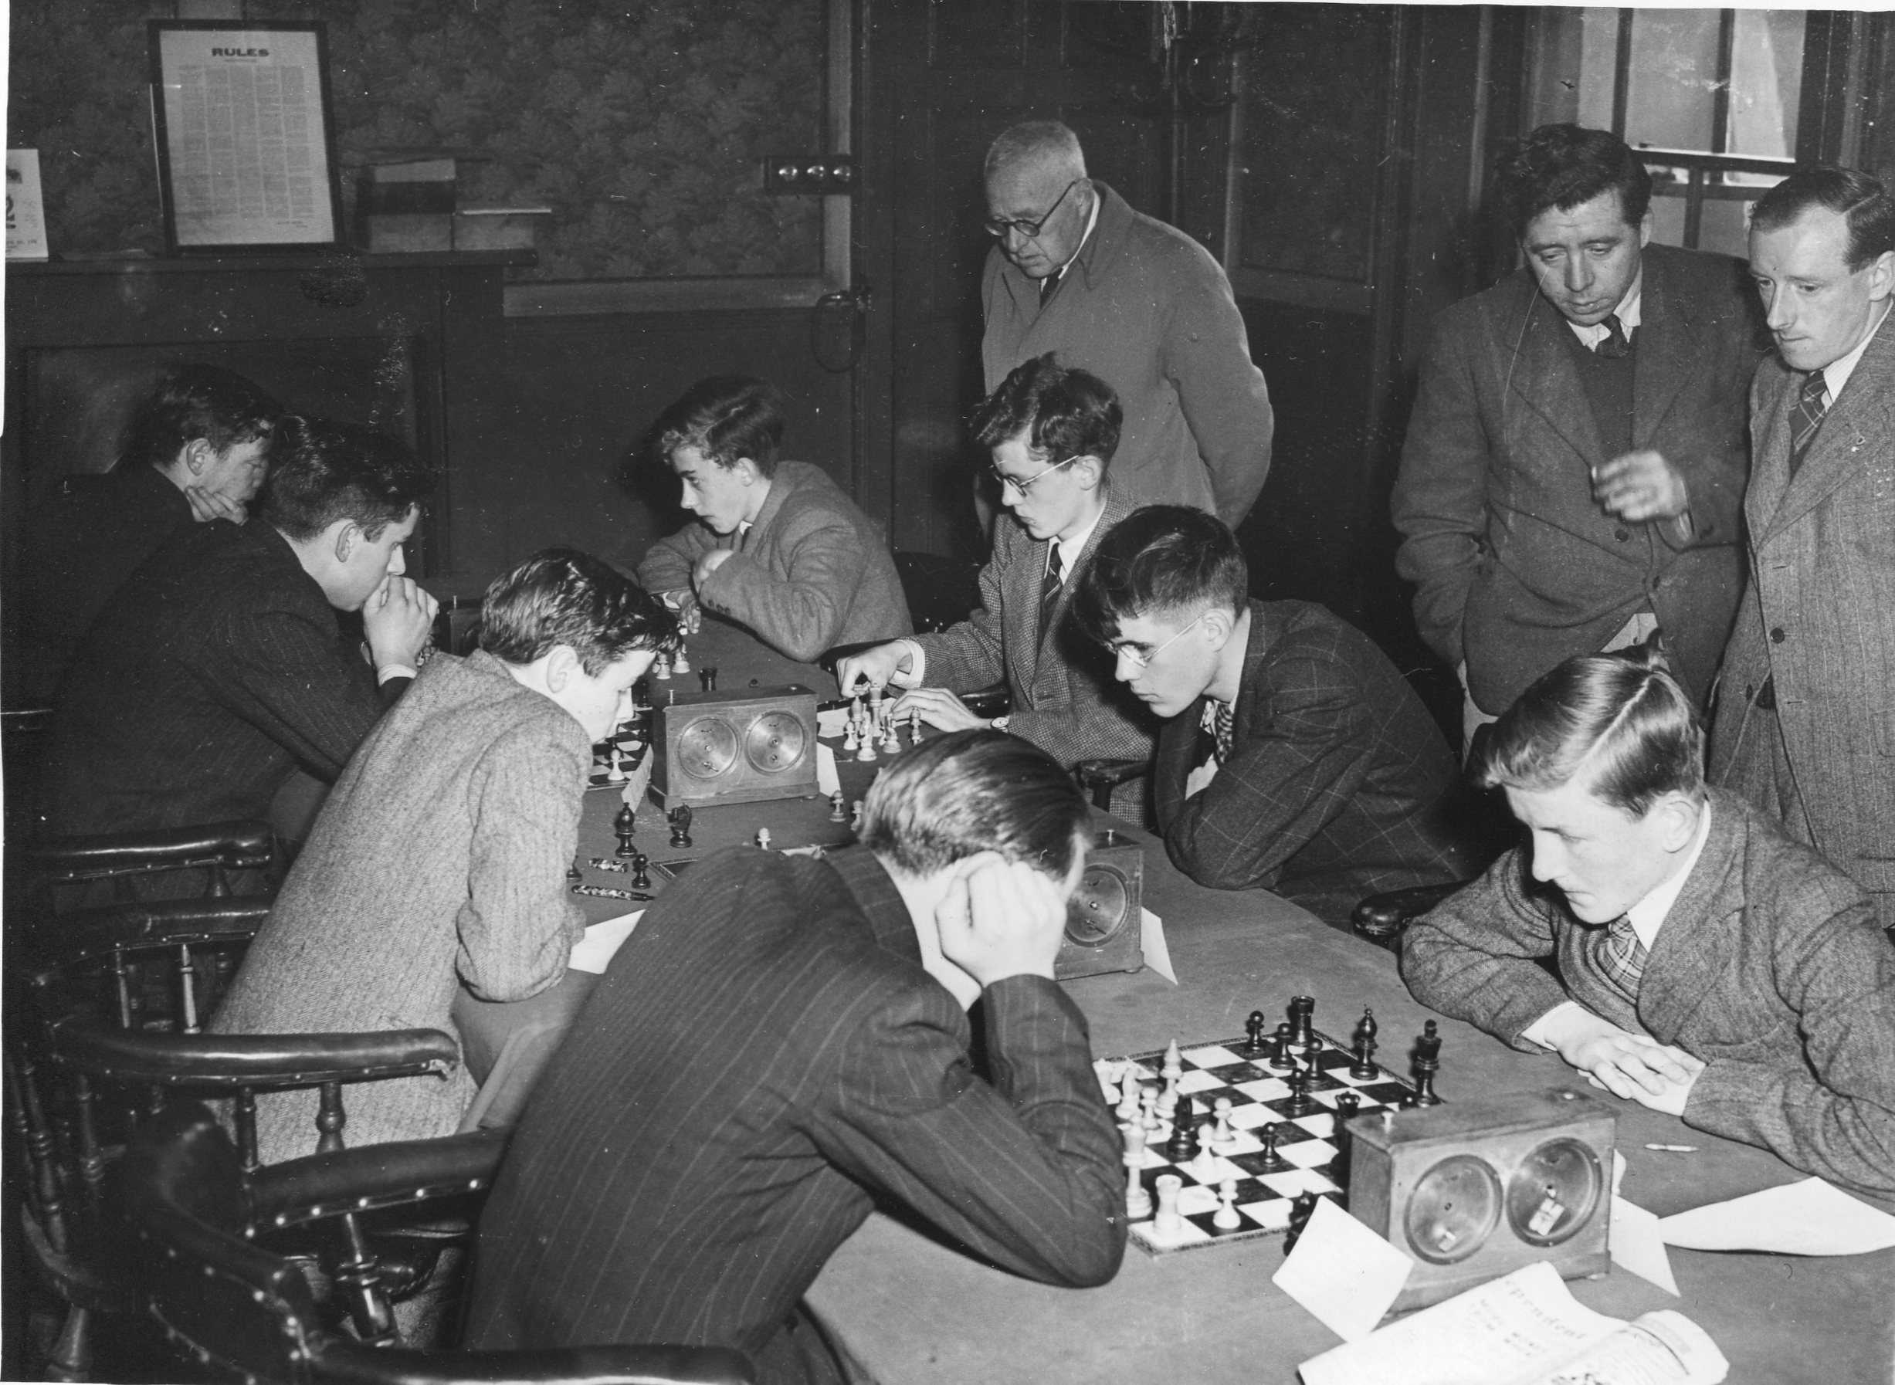
(IRL) Irish Chess
Marshall is nearest the camera with his head in his hands
studying his game against the Irish top board, Michael Fagan.

He was well thought of at senior level too. In April 1949 he played on Board 12 for South Wales in a 39 board match against Monmouthshire
This obituary appears on Google Arts & Culture:
Walter Charles Marshall, Baron Marshall of Goring CBE FRS was a noted theoretical physicist and leader in the UK's energy sector. The son of Frank Marshall and Amy Pearson, he studied mathematical physics at Birmingham University and gained a PhD there under Rudolf Peierls. In 1955 he married Ann Sheppard in Cardiff and had a son and daughter. He joined the Theoretical Physics Division at AERE Harwell in 1954, succeeding Brian Flowers as Head of that Division in 1960 and becoming Director of AERE in 1968; he eventually was appointed Chairman of the United Kingdom Atomic Energy Authority in 1981. Appointed a Commander of the Order of the British Empire in 1973, he was Knighted in 1982. As a champion of nuclear power, he was appointed, in 1983, to be chairman of the Central Electricity Generating Board. For his success in keeping the country's “lights on” during the protracted miners’ strike of 1984–5, Margaret Thatcher rewarded him with a life peerage and he became Baron Marshall of Goring, of South Stoke in the County of Oxfordshire on 22 July 1985.

Keith Peters
1938-
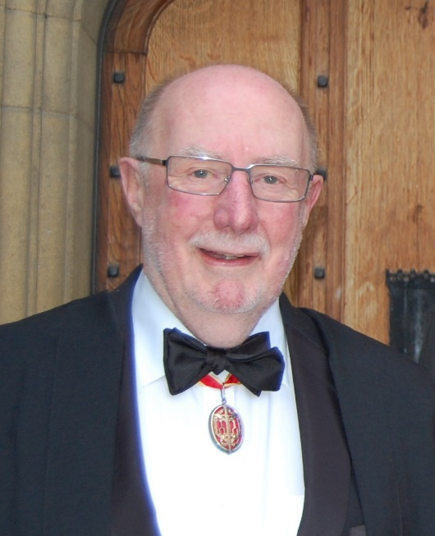

Keith Peters was born in Baglan and educated at Glan Afan Grammar School in Port Talbot. He graduated in medicine from the Welsh National School of Medicine in 1961.

He played in the Glorney Cup team on one of the lower boards in 1953 and led the side the following year when the event was held in Cardiff. He played again in 1955, this time on Board 2. In 1955 he won the first ever Welsh Under 18 Championship.

At this time, Port Talbot boasted one of the most successful clubs in Wales. They did not have very strong players or even great strength in depth, but succeeded in winning the South Wales Challenge Cup in 1947 and 1954 and the West Wales League six times between 1938 and 1955. Keith Peters played for the club at the latter end of this period and was in the team that won the Challenge Cup final against Barry in 1954. He also played in the grand East v. West match in February that year alongside many of his club colleagues.

This resume of his career appears on the Academy of Medical Sciences website:

After posts in the University of Birmingham, the National Institute for Medical Research at Mill Hill and the Welsh National School of Medicine, he was appointed Lecturer in Medicine and Consultant Physician at the Royal Postgraduate Medical School (RPMS), Hammersmith Hospital. Between 1969 and 1975 he was successively Lecturer in Medicine, Lecturer in Medicine and Immunology, and Reader in Medicine, before being appointed Professor of Medicine and Director of the Department of Medicine at the Royal Postgraduate Medical School in 1977. In 1987 Sir Keith became Regius Professor of Physic in the University of Cambridge and head of the School of Clinical Medicine.
Keith Peters' research interests centre on the immunology of renal and vascular disease, and in particular on how delineation of immunological mechanisms can lead to new therapies for these disorders. He was Knighted in the 1993 New Year's Honours List and was made Fellow of the Royal Society in 1995. His major contributions to UK medicine have been through the promotion of clinical research.
Sir Keith was elected a Fellow of the Academy in 1998.

Brian David Josephson
1940-
Brian was probably the weakest chess player of the three players featured here. He was educated at Cardiff High School which by that time already had a long history of producing fine young chess players. He played in the Glorney Cup team on one of the lower boards in 1956 and competed in the Welsh senior championships Reserves tournament in 1959 whilst reading mathematics at Trinity College, Cambridge. He was one of three joint winners and played the following year in the Championship itself without success.
Brian Josephson is best known for his pioneering work on quantum tunnelling and superconductivity. He was 22 years old when he did the work on a quantum mechanical phenomenon that won him Nobel Prize.
Quantum physics describes matter as both particles and waves. In quantum tunnelling, a subatomic particle passes through a potential barrier, and this phenomenon cannot be predicted by the laws of classical mechanics.
In 1962, Josephson came up with a new phenomenon of supercurrent, in which he predicted some unexpected results with superconductors. Superconductors are materials that lack electrical resistance at low temperatures.
He found that without superimposed voltage, current can pass through two superconductors separated by a thin insulator. If a rectified voltage is added, an alternating current can result.
The photo and article appeared in ‘RankRed’ featuring the twelve youngest Nobel prize winners.

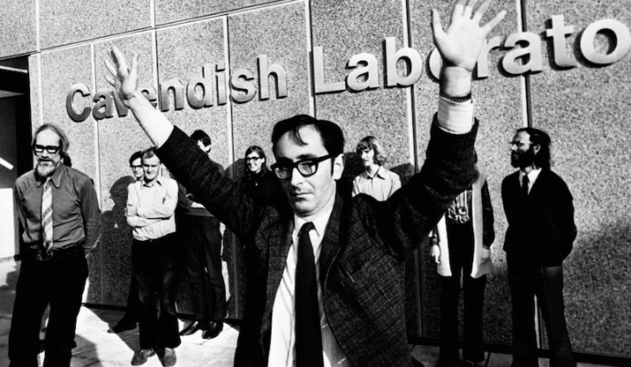
Pictured after winning the Nobel prize at the age of 33.

W alter Marshall, Keith Peters and Brian Josephson could have been amongst the best ever Welsh chess players but perhaps wisely chose to abandon the competitive game and achieve greatness elsewhere.

